TOPIC :-
RSA encryption and decryption
DEFINITION :-
RSA encryption is the process of converting plain text into cipher text using a public key , It insures that only the intended recipient , who holds the private key , can decrypt the message.
TOOLS :-

Online website using

STEP 1:-
Go to the search bar and search RSA encryption and decryption
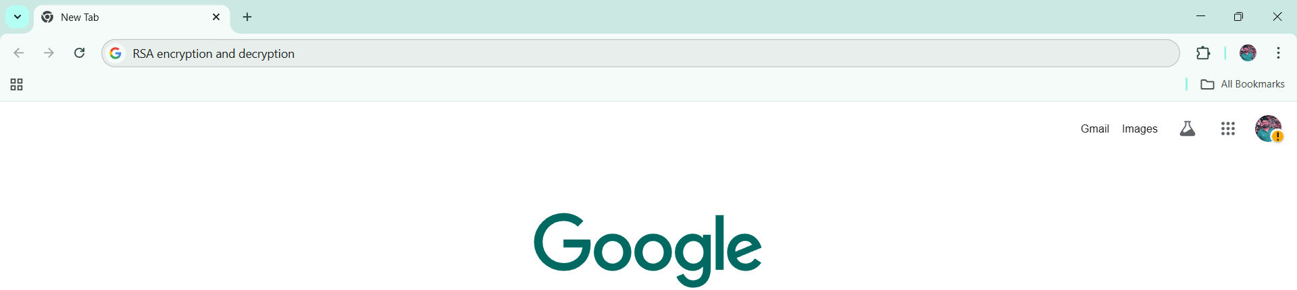
STEP 2:-
Open first website Dev glan RSA encryption decryption & key generator tool online
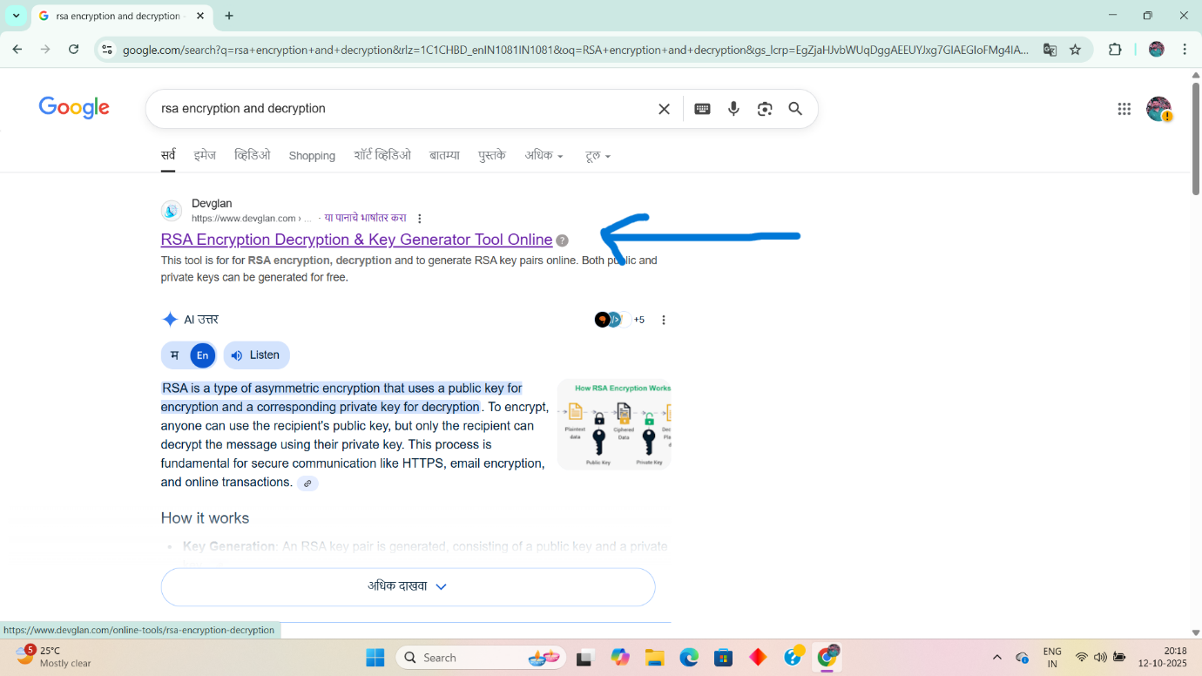

STEP 3:-
Click on generate RSA pair


STEP 4:-
Enter the text on RSA encryption box then click on encrypt
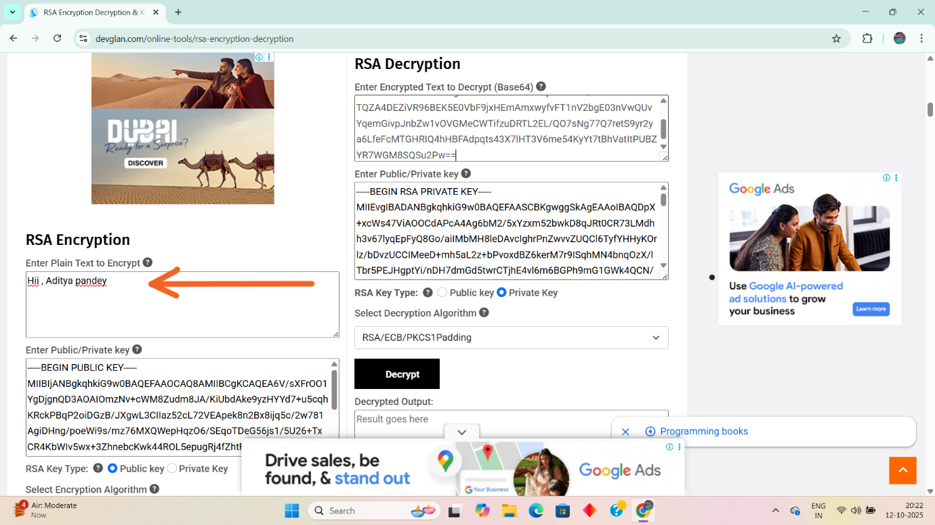
STEP 5:-
Copy the encrypted output and paste on the RSA decryption box
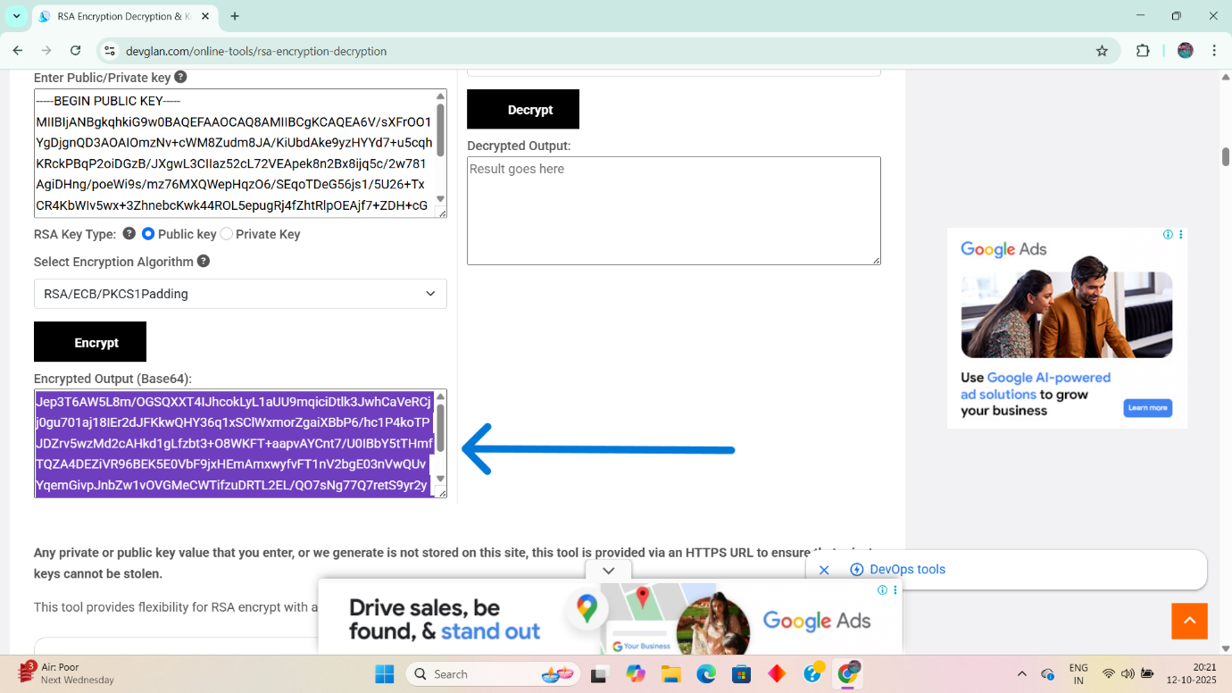

STEP 6:-
Then click on the decrypt . Then you see the encrypted text in the decrypted output .
